**KULLIYYAH OF INFORMATION AND**

**COMMUNICATION TECHNOLOGY**

**CSC 1100 – Elements of Programming**

**Semester 1 2018/2019**

**Section: [1]**

**Project Final Report**

## Auto parking system

**Group Members :**

|  |  |
| --- | --- |
| **Ramzi Ahmad** |  |
| **Conde Lancine** |  |
| **Abdelrahman Abdelaziz Ahmad** |  |
| **Hanan Haidar Alatas** |  |

**Supervised by**

**Dr. Suriani Sulaiman**

1. **INTRODUCTION:**

Our project is about **Auto parking system**. The program has three options; register and get a ticket, display available parking spot and, available vehicle services. Firstly, register and get a ticket allows the customers making record either for their car or motor bike, will calculate the fare for parking based on this two specification per hour. The customers will enter whether it is week-end or week-day, then they will choose in which level do they want to park their vehicle from three levels , and for how many hours they want to park. The program will display how many parking spot are available and how many are already booked on that level. Customers can choose which spot they want. Secondly, the program will print out the receipt for the customer including ticket number and all information that they has entered. Lastly, customer can choose vehicle service for their car or motor bike. Our program provide two types of vehicle services Wash and vacuum.

1. **FLOW CHART:**

PRINT OPTIONS

CREATE CLASS OBJECT

INPUT CHOICE

CALL FUNCTION

CASE 1

PAT BILL

DISPLAY SERVICES

NEW INSERT

OPEN FILE

CASE 2

DISPLAY SPOTS

PASS OBJECT TO FILE

CASE 3

CLOSE FILE

CASE 4

OPEN FILE

LOAD DATA FROM FILE

INPUT HOURS

PRINT AVAILABLE SPOT

CALL CALCULATE

SHOW ALL RECORDS FROM FILE

CLOSE FILE

CALCULATE THE BILL

CLOSE THE FILE

PRINT TOTAL BILL

1. **LIST OF PROGRAM FUNCTIONS:**

void Display(); : function for customer to register and get the ticket .

void get_weekend(); : function to ask users if it is weekend .

void get_level(); : function to display which level the user want to park from three levels.

void get_hours(); : function to display how many hours they want to park their vehicle.

void ShowServices(); : function to display the process to show types of services that our program has.

void get_service_car(); : function to display types of services are provide for cars.

void get_service_Motor(); : function to display types of services provide for Motor bike.

void getSpot(); : function to display the spots from 25 spots.

void bookSpot(int,int,bool); : function that help to book available spot and mark the non available spot that already booked.

void showMatrics (bool[]); : function to show scheme of the parking number.

void availableSpot(int); : function to display available spots.

void showtik(); : function to show tickets.

void calcdate(); : function to display the process for date.

double get_total(double,double); : function to calculate the total before it shows receipt

bool checkSpot(int,int); : function to check how many available spots are there.

double calctotal(); : function to calculate the total.

1. 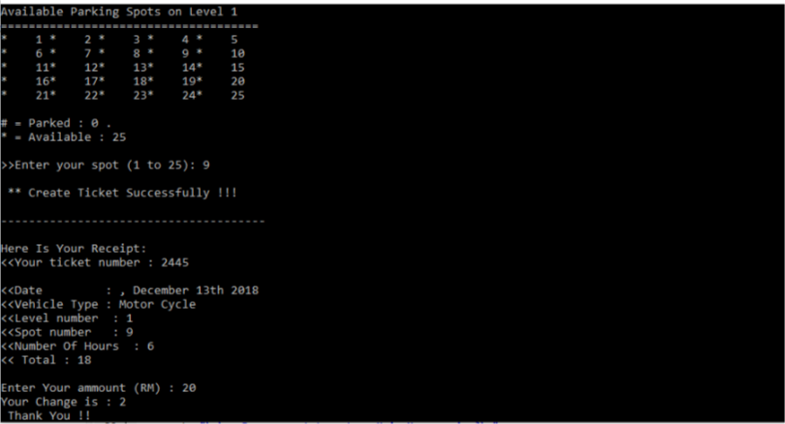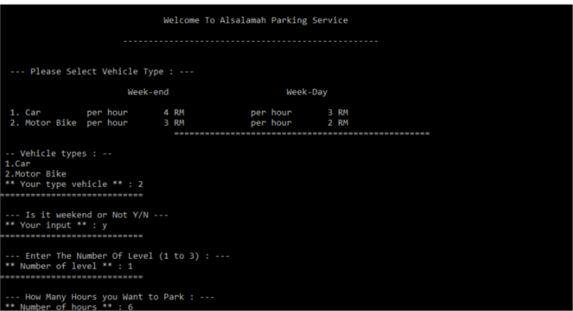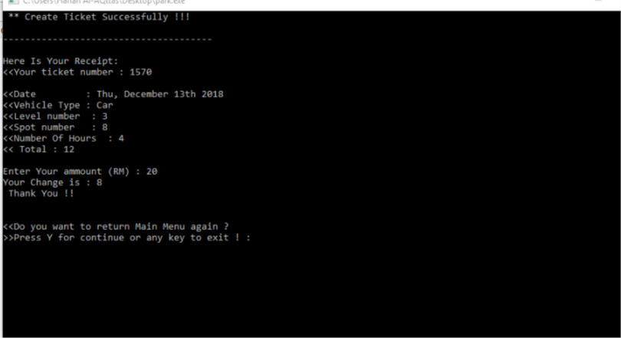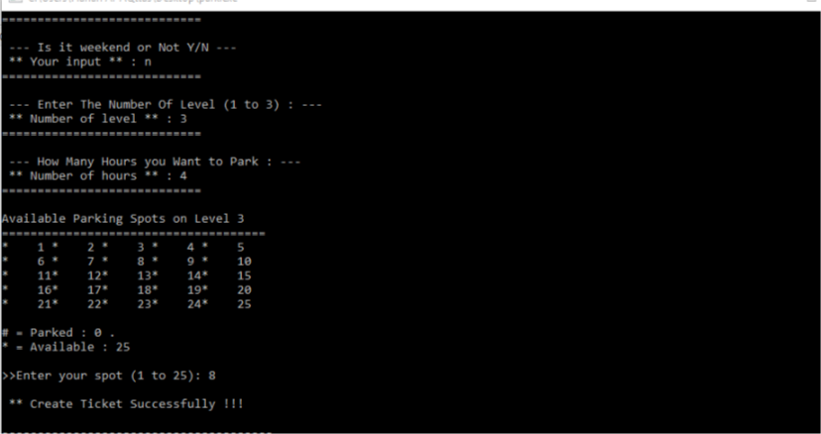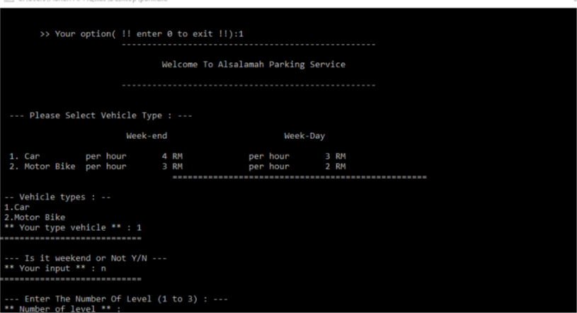**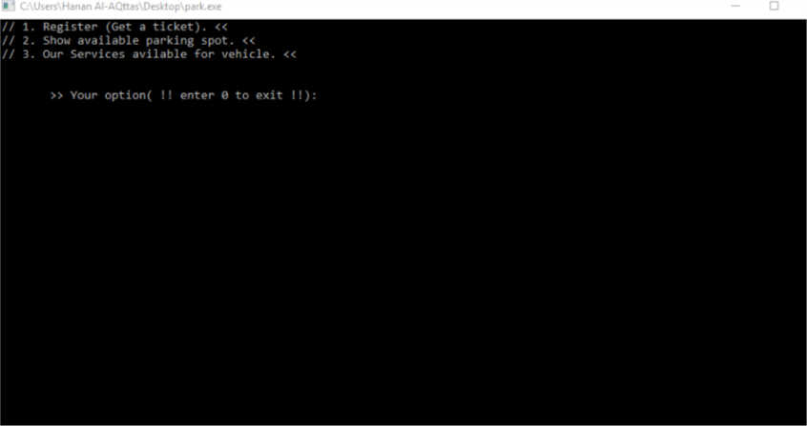SAMPLE OF SCREENSHOTS**

